Regulatory Committee
Meeting to be held on 19 September 2018

Electoral Division affected:
Lancaster Rural North

Wildlife and Countryside Act 1981
Definitive Map Modification Order Investigation
Addition of Footpath from Kellet Road to Dunkirk Avenue, Carnforth
File Number 804-593
(Annex ‘A’ refers)

Contact for further information:
Claire Blundell, 01772 535604, Paralegal Officer, Legal and Democratic Services, Claire.blundell@lancashire.gov.uk
Jayne Elliott, 01772 537663, Public Rights of Way Officer, Planning and Environment Group, jayne.elliott@lancashire.gov.uk

Executive Summary

Application for the addition of a footpath from Kellet Road to Dunkirk Avenue, Carnforth to be recorded on the Revised Definitive Map and Statement, in accordance with File Number 804-593.

Recommendation

That the application for the addition to the Definitive Map and Statement of a

Public Footpath from Kellet Road to Dunkirk Avenue, Carnforth, in accordance with File Number 804-593, be accepted

That an Order be made pursuant to Section 53 (2)(b) and Section 53 (3)(b)

and Section 53 (3)(c)(i) of the Wildlife and Countryside Act 1981 to add a Public Footpath from Kellet Road to Dunkirk Avenue, Carnforth to the Definitive Map and Statement of Public Rights of Way as shown on Committee Plan between points A-B-C-D-E-F.

That being satisfied that the higher test for confirmation can be met the Order

be promoted to confirmation.

Background

An application under Schedule 14 of the Wildlife and Countryside Act 1981 has been received for the addition to the Definitive Map and Statement of Public Rights of Way of a public footpath from Kellet Road to Dunkirk Avenue, Carnforth as shown by a thick dashed line between points A-B-C-D-E-F on the Committee plan.

A further application has also been submitted for a footpath to the south of this route which included the section E-F.

The county council is required by law to investigate the evidence and make a decision based on that evidence as to whether a public right of way exists, and if so its status. Section 53(3)(b) and (c) of the Wildlife and Countryside Act 1981 set out the tests that need to be met when reaching a decision; also current Case Law needs to be applied.

An order will only be made to add a public right of way to the Definitive Map and Statement if the evidence shows that:
- A right of way “subsists” or is “reasonably alleged to subsist”

An order for adding a way to or upgrading a way shown on the Definitive Map and Statement will be made if the evidence shows that:
- “the expiration… of any period such that the enjoyment by the public…raises a presumption that the way has been dedicated as a public path or restricted byway”

When considering evidence, if it is shown that a highway existed then highway rights continue to exist (“once a highway, always a highway”) even if a route has since become disused or obstructed unless a legal order stopping up or diverting the rights has been made. Section 53 of the Wildlife and Countryside Act 1981 makes it clear that considerations such as suitability, the security of properties and the wishes of adjacent landowners cannot be considered. The Planning Inspectorate’s website also gives guidance about the interpretation of evidence.

The county council’s decision will be based on the interpretation of the evidence discovered by officers and documents and other evidence supplied by the applicant, landowners, consultees and other interested parties produced to the county council before the date of the decision. Each piece of evidence will be tested and the evidence overall weighed on the balance of probabilities. It is possible that the council’s decision may be different from the status given in any original application. The decision may be that the routes have public rights as a footpath, bridleway, restricted byway or byway open to all traffic, or that no such right of way exists. The decision may also be that the routes to be added or deleted vary in length or location from those that were originally considered.

Consultations

Lancaster City Council

The Lancaster City Council responded to consultations. They had nothing to substantiate an objection to the application but provided that the site was previously used as a garage site by local residents on the Highfield housing estate and the garages were demolished and removed some years ago leaving the site vacant and unsecured. They advised the county council that the city council has proposals for a small new development to provide affordable housing to the local people of Carnforth. The city council is of the opinion that the claimed footpath route is important for providing pedestrian flow within the local neighbourhood from the Highfield housing estate to and from the proposed housing developments on Lundsfield.

Carnforth Town Council

The town council did not provide any comments in objection or support therefore it is presumed they have no comments to make.

Applicant/Landowners/Supporters/Objectors

The evidence submitted by the applicant/landowners/supporters/objectors and observations on those comments are included in Advice – Head of Service – Legal and Democratic Services Observations.

Advice

Head of Service – Planning and Environment

Points annotated on the attached Committee plan.

Point | Grid Reference (SD) | Description
A | 5011 7039 | Open junction of quarry track with Kellet Road
B | 4990 7017 | Junction of track with informal path
C | 4989 6993 | SE corner of concrete area
D | 4996 6979 | 'T' junction of tracks
E | 4996 6972 | Security fence and gate
F | 5000 6971 | Open junction with Dunkirk Avenue and Windermere Road

Description of Route

A site inspection was carried out on 20 February 2018.

From an open junction (point A) with Kellet Road the entrance of stone and broken tarmac is closed by recently erected high metal security gates and fencing a few metres south of the road. The route continues along a 4m wide stone surfaced track initially south with trees and bushes set back from either side. The Lancaster Canal is visible to the west and fencing at the rear of the housing estate visible to the east. The route gently curves to the west with a hedge between the track and the canal on the north side and scrubby woodland to the south.

After 365m a fairly new Homes England sign stating 'Private Land No public access or right of way' and an old illegible sign face the track from the land on the south side. Immediate west of these signs an informal path joins the track (B) and the route turns south along this path between a few trees and along the edge of a large deteriorating concreted area.

After about 200m at the south east corner of the concrete area the route continues for a further 50m generally south across a grass and gravel area criss-crossed by trodden paths to meet a more district gravel track (C). The route now turns south east along this track gently uphill with the track becoming more defined as it approaches the boundary of the site, curving south, parallel to the boundary fence and hedge, to a junction with a grass track to the west after 160m (D).

The route continues for 70m on a straight grass track, bounded by hedges on both sides to a security fence and gate across the track (E) and immediately after this turns east via a small metal ladder stile adjacent to a padlocked field gate with concrete blocks in front of it.

The route follows a hard surface track east south east for 50m to a junction with Dunkirk Avenue and Windermere Road.

The total length of the route is approximately 900 metres.

Map and Documentary Evidence

Document Title | Date | Brief Description of Document & Nature of Evidence
Yates’ Map  of Lancashire | 1786 | Small scale commercial map. Such maps were on sale to the public and hence to be of use to their customers the routes shown had to be available for the public to use. However, they were privately produced without a known system of consultation or checking. Limitations of scale also limited the routes that could be shown.
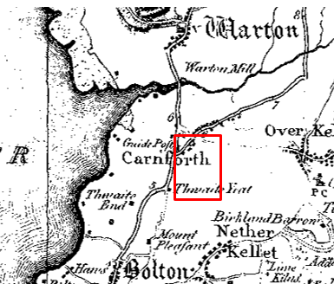
Observations |  | The route is not shown on Yate's Map. Kellet Road may have existed although it is only shown in faint outline but Dunkirk Avenue and Windermere Road – to which the route links are not shown and probably didn't exist.
Investigating Officer's Comments |  | The route is unlikely to have existed in 1786 and if it did exist as a minor route (even in part) was not shown due to limitations of scale so no inference can be drawn in this respect.
Greenwood’s Map of Lancashire | 1818 | Small scale commercial map. In contrast to other map makers of the era Greenwood stated in the legend that this map showed private as well as public roads and the two were not differentiated between within the key panel.
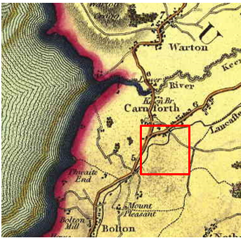
Observations |  | Kellet Lane is shown but Dunkirk Avenue and Windermere Road are not. The canal is shown which runs parallel to the application route between point A and point B but the route is not shown.
Investigating Officer's Comments |  | The route did not exist as a major route at the time but it may have existed as a minor route which would not have been shown due to the limitations of scale so no inference can be drawn in this respect.
Hennet's Map of Lancashire | 1830 | Small scale commercial map. In 1830 Henry Teesdale of London published George Hennet's Map of Lancashire surveyed in 1828-1829 at a scale of 71/2 inches to 1 mile. Hennet's finer hachuring was no more successful than Greenwood's in portraying Lancashire's hills and valleys but his mapping of the county's communications network was generally considered to be the clearest and most helpful that had yet been achieved.
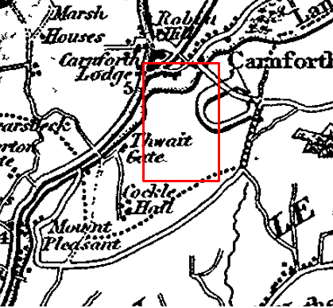
Observations |  | The application route is not shown.
Investigating Officer's Comments |  | The route did not exist as a major route at the time but it may have existed as a minor route which would not have been shown due to the limitations of scale so no inference can be drawn in this respect.
Canal and Railway Acts |  | Canals and railways were the vital infrastructure for a modernising economy and hence, like motorways and high speed rail links today, legislation enabled these to be built by compulsion where agreement couldn't be reached. It was important to get the details right by making provision for any public rights of way to avoid objections but not to provide expensive crossings unless they really were public rights of way. This information is also often available for proposed canals and railways which were never built.
Observations |  | The route between point A and point B runs parallel to the Lancaster canal. Plans and records relating to the Lancaster Canal have been examined in the County Records Office but no reference to the route was found.
Investigating Officer's Comments |  | No inference can be drawn.
Tithe Map and Tithe Award or Apportionment | 1846 | Maps and other documents were produced under the Tithe Commutation Act of 1836 to record land capable of producing a crop and what each landowner should pay in lieu of tithes to the church. The maps are usually detailed large scale maps of a parish and while they were not produced specifically to show roads or public rights of way, the maps do show roads quite accurately and can provide useful supporting evidence (in conjunction with the written tithe award) and additional information from which the status of ways may be inferred.
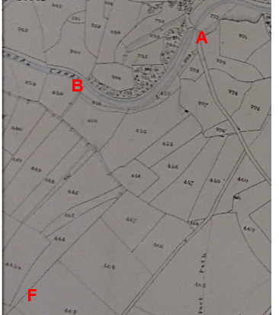
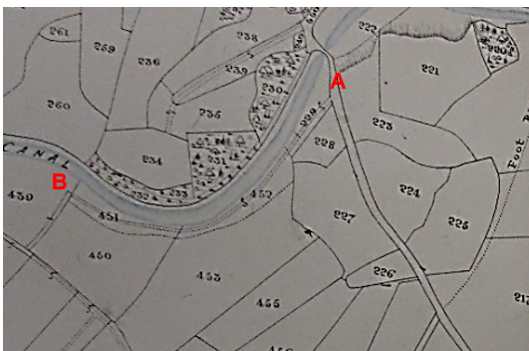
Observations |  | A track depicted by double pecked lines is shown consistent with the application route between point A and point B passing through numbered plots 229, 452 and 451. From point B the application route follows a track shown passing through plot 430 and beyond there through to point F is not shown.
Investigating Officer's Comments |  | The application route between point A and point B and part way to point C existed as a physical track in 1846. The rest of the application route through to point F did not exist. There is no indication in the Tithe Award that the route was considered to be a public footpath at that time.
Inclosure Act Award and Maps |  | Inclosure Awards are legal documents made under private acts of Parliament or general acts (post 1801) for reforming medieval farming practices, and also enabled new rights of way layouts in a parish to be made. They can provide conclusive evidence of status.
Observations |  | There is no Inclosure Award in the County or National Archives for the land crossed by the application route.
Investigating Officer's Comments |  | No inference can be drawn.
6 Inch Ordnance Survey (OS) Map | 1848 | The earliest Ordnance Survey 6 inch map for this area surveyed in 1845 and published in 1848.
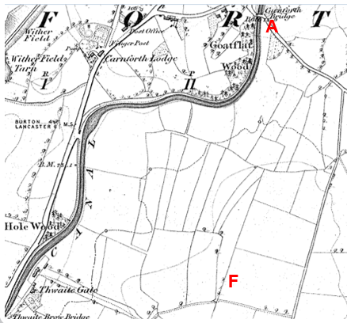
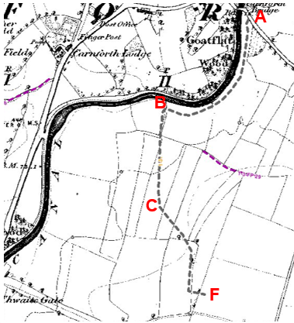
Observations |  | The application route is not shown and crosses a number (at least 8) of field boundaries.
Investigating Officer's Comments |  | The application route did not exist in 1845 (date of survey) although it should be noted that part of the route (from point A-B-partway to point C) was shown on the Tithe Map dated 1846 – post- dating the OS survey and predating publication of the 6 inch map.
25 Inch OS Map | 1891 | The earliest OS map at a scale of 25 inch to the mile. Surveyed in 1890 and published in 1891.
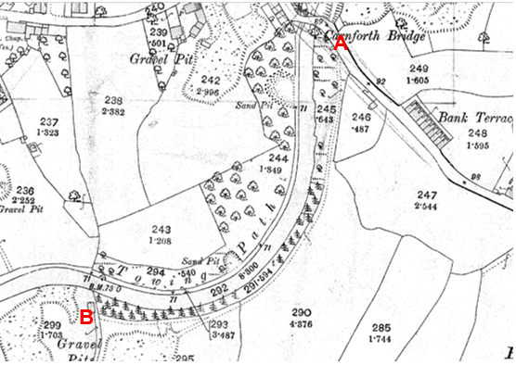
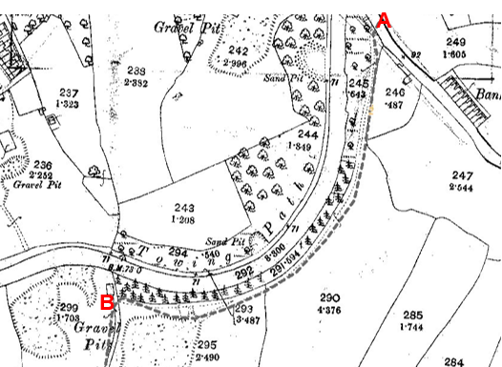
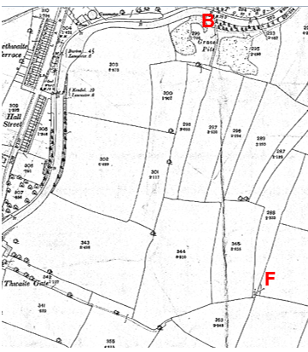
Observations |  | A track largely consistent with the application route is shown from point A to point B providing access to gravel pits south of point B and for a short distance from point B leading towards point C. The rest of the application route is not shown.
Investigating Officer's Comments |  | A track largely consistent with the application route existed between point A and point B (and slightly beyond) and may have been capable of being used but did not form part of a through route. The rest of the application route did not exist in 1890.
25 inch OS Map | 1913 | Further edition of the 25 inch map surveyed in 1890, revised in 1910 and published in 1913.
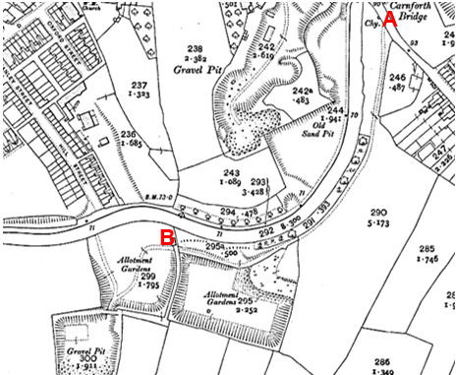
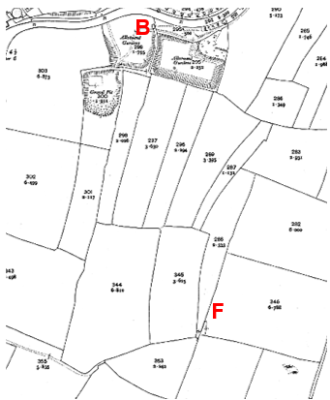
Observations |  | A track is shown from point A to point B providing access to allotment gardens (formerly gravel pits). The rest of the application route is not shown.
Investigating Officer's Comments |  | The application route existed on the ground between point A and point B in 1910 but the rest of the application route did not exist.
Finance Act 1910 Map | 1910 | The comprehensive survey carried out for the Finance Act 1910, later repealed, was for the purposes of land valuation not recording public rights of way but can often provide very good evidence. Making a false claim for a deduction was an offence although a deduction did not have to be claimed so although there was a financial incentive a public right of way did not have to be admitted.  Maps, valuation books and field books produced under the requirements of the 1910 Finance Act have been examined. The Act required all land in private ownership to be recorded so that it could be valued and the owner taxed on any incremental value if the land was subsequently sold. The maps show land divided into parcels on which tax was levied, and accompanying valuation books provide details of the value of each parcel of land, along with the name of the owner and tenant (where applicable).  An owner of land could claim a reduction in tax if his land was crossed by a public right of way and this can be found in the relevant valuation book. However, the exact route of the right of way was not recorded in the book or on the accompanying map. Where only one path was shown by the Ordnance Survey through the landholding, it is likely that the path shown is the one referred to, but we cannot be certain. In the case where many paths are shown, it is not possible to know which path or paths the valuation book entry refers to. It should also be noted that if no reduction was claimed this does not necessarily mean that no right of way existed.
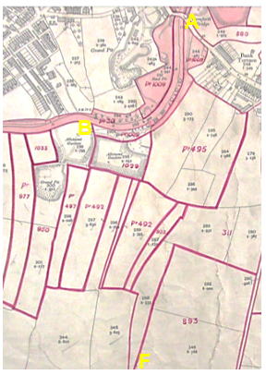
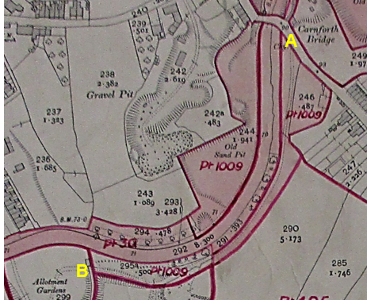
Observations |  | Between point A and point B the application route passes through plot 1009 which was owned and occupied by the London and North Western Railway Company and is described as 'canal and works.' No deduction was claimed for public rights of way or user and no deductions were claimed for any of the other numbered plots through which the application route runs.
Investigating Officer's Comments |  | The Valuation records do not provide any supporting evidence regarding the existence of the route in 1910.
25 Inch OS Map |  | The 'third' edition of the 25 inch OS map was published in the 1930s. The county council does not have a copy of this map and it could not be found online.
Investigating Officer's Comments |  | No inference can be drawn.
Aerial Photograph | 1940s | The earliest set of aerial photographs available was taken just after the Second World War in the 1940s and can be viewed on GIS. The clarity is generally very variable.
Observations |  | No aerial photographs covering the area crossed by the application route were available to view.
Investigating Officer's Comments |  | No inference can be drawn.
6 Inch OS Map | 1956 | The OS base map for the Definitive Map, First Review, was published in 1956 at a scale of 6 inches to 1 mile (1:10,560). This map was revised before 1930 and is probably based on the same survey as the 1930s 25-inch map.
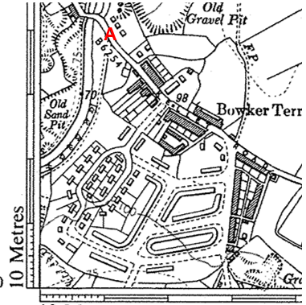
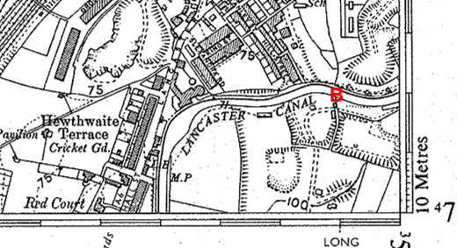
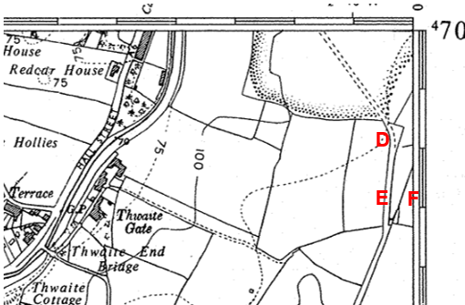
Observations |  | The application route is shown between point A and point E and continues south from point E. The route between point E and point F is not shown.
Investigating Officer's Comments |  | The application route existed as a substantial track between point A and point E in the 1930s and may have been capable of being used. It did not form part of a through route to Dunkirk Avenue/Windermere Road at that time.
Aerial photograph | 1960s | The black and white aerial photograph taken in the 1960s and available to view on GIS.

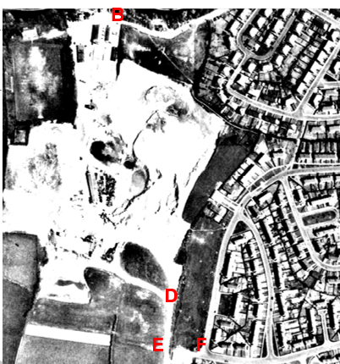
Observations |  | The photograph clearly shows the application route between point A and point B as a substantial vehicular access route into the working quarry site. Between point B and point D the route is not visible and looks to cross the sand and gravel quarry site with no obvious or clear way through. From point D to point E the application route is clearly visible as a worn track. There is no apparent route from point E to point F although the photograph confirms the existence of Dunkirk Avenue and Windermere Road by the 1960s.
Investigating Officer's Comments |  | Most of the route crossed a working sand and gravel quarry with parts (A-B and D-E) being clearly consistent with quarry access roads.  Access may have been available to parts of the route but it appears unlikely that the route in its entirety was being used as a public through route on foot at that time.
1:2500 OS Map | 1972 | Further edition of 25 inch map reconstituted from former county series and revised in 1969-70 and published 1972 as national grid series.
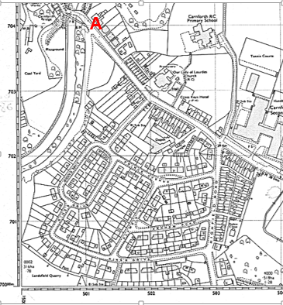
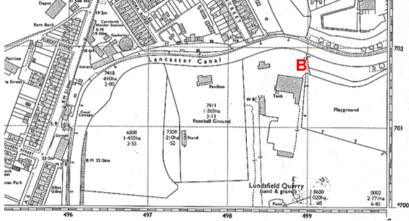
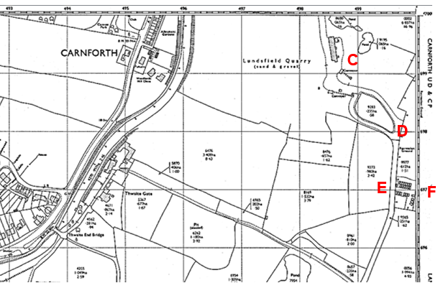
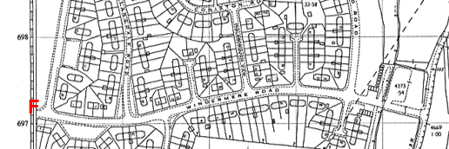
Observations |  | The application route can be clearly seen as an open track extending from Kellet Road at point A to point B where it appears to be gated at the entrance to the quarry site. West of the quarry a football ground is marked with the only access to it appearing to be via the application route A-B and then across the quarry site.  From point B the application route does not appear to be accessible as it passed through a large building and pond. From south of point C a track consistent with the application route is shown continuing through point D and point E and then south to connect to a further quarry. From point E a line is shown across the application route and beyond that the route appears accessible alongside some garages to point F at the junction with Dunkirk Ave. and Windermere Rd.
Investigating Officer's Comments |  | Parts of the application route existed as access to the quarry and possibly also providing access to a football pitch. However the route passed through a working sand and gravel quarry and did not appear to be an accessible through route at that time.
Aerial Photograph | 1988 | Aerial photograph available to view at the County Records Office.
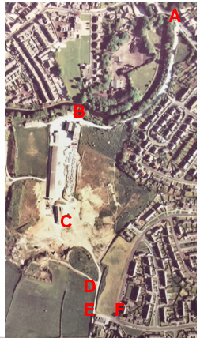
Observations |  | The quarry buildings are clearly visible but it is not clear whether the site is still operational. The track between point A and point B is clearly visible and appears to provide vehicular access to the quarry buildings and to the football pitches west of point B. Access onto the route is also visible midway between point A and point B from the housing estate to the east of the route.  The application route between point B and point C is not clearly visible although access may have been possible to the east of the quarry buildings on the line claimed. From point C through point D to point E the application route appears available – crossing an open area at point C and then following a track down to point E. From point E to point F the route through to Dunkirk Avenue/Windermere Road is clearly visible as a wide track. It is not possible to see from the photograph whether any gates or barriers prevented or restricted access.
Investigating Officer's Comments |  | The application route may have been accessible in 1988 although the route between point B and point C could have differed from what has been claimed.
Aerial Photograph | 2000 | Aerial photograph available to view on GIS.
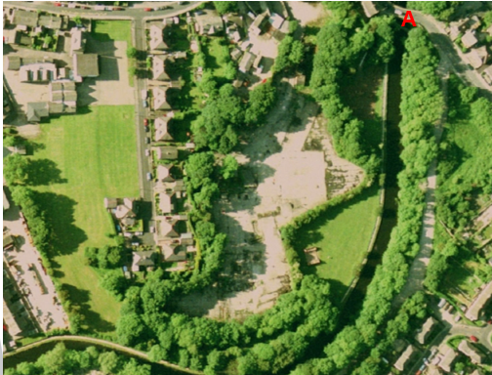
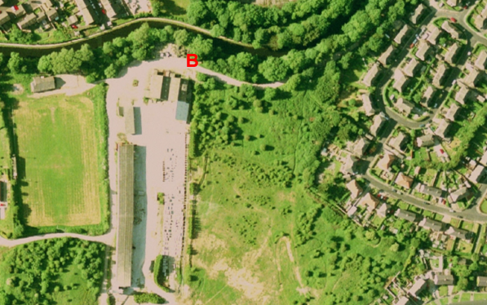
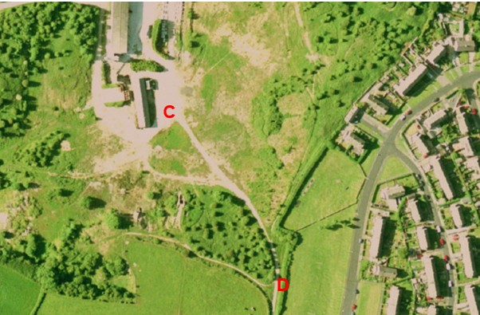
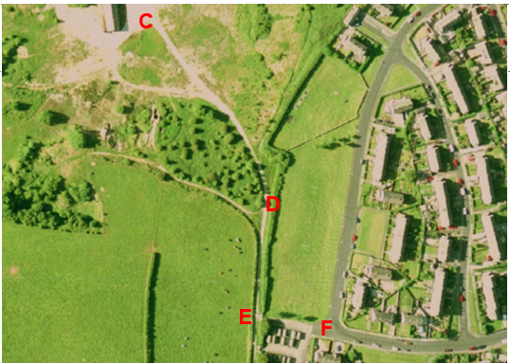
Observations |  | Part of the application route between point A and point B is obscured by trees but still appears to be the main vehicular access to the quarry site, football pitch and marina. A route between point B and point C appears to be available although it looks to deviate east through an area of trees away from the buildings from point B. the route is clearly visible between point C and point D, continuing to (and past) point E. From point E a worn route can be seen through the gateway at point E to point F. It is not possible to see from the photograph whether any gates or barriers prevented or restricted access.
Investigating Officer's Comments |  | The application route appeared to exist in 2000 although it is not possible to confirm from the photograph whether the exact route claimed between point B and point C was available nor whether any barriers were in place along the route.
Aerial photograph | 2016 | Aerial photograph available to view on GIS.
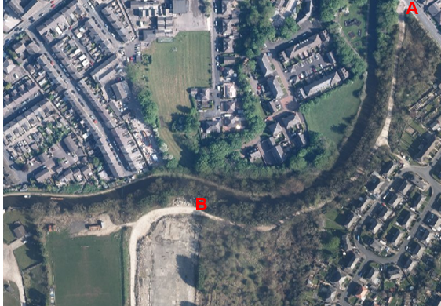
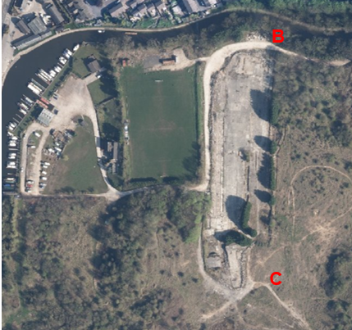
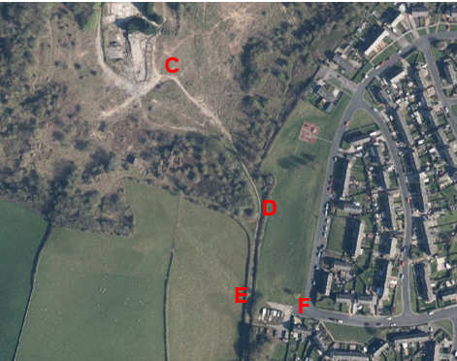
Observations |  | The quarry site now appears to be derelict and the buildings demolished. The track between point A and point B is clearly visible (despite tree cover) and looks to provide access to the football pitch and also to the Marina.  A route between point B and point C may have been accessible but does not show up on the photograph as a worn track. From point C-D-E the application route can be clearly seen as a worn track. Tree cover means that it is not possible to see whether access was available at point E (through to point F).
Investigating Officer's Comments |  | The application route may have existed in 2016 although the way between point B and point C may have differed from the one applied for.
Definitive Map Records |  | The National Parks and Access to the Countryside Act 1949 required the county council to prepare a Definitive Map and Statement of Public Rights of Way.  Records were searched in the Lancashire Records Office to find any correspondence concerning the preparation of the Definitive Map in the early 1950s.
Parish Survey Map | 1950-1952 | The initial survey of public rights of way was carried out by the parish council in those areas formerly comprising a rural district council area and by an urban district or municipal borough council in their respective areas. Following completion of the survey the maps and schedules were submitted to the county council. In the case of municipal boroughs and urban districts the map and schedule produced, was used, without alteration, as the Draft Map and Statement. In the case of parish council survey maps, the information contained therein was reproduced by the county council on maps covering the whole of a rural district council area. Survey cards, often containing considerable detail exist for most parishes but not for unparished areas.  Carnforth was an Urban District Council for which no parish survey map was prepared.
Draft Map |  | The Draft Maps were given a “relevant date” (1st January 1953) and notice was published that the draft map for Lancashire had been prepared. The draft map was placed on deposit for a minimum period of 4 months on 1st January 1955 for the public, including landowners, to inspect them and report any omissions or other mistakes. Hearings were held into these objections, and recommendations made to accept or reject them on the evidence presented.
Observations |  | The route was not shown on the Draft Map and no representations were made to the county council.
Provisional Map |  | Once all representations relating to the publication of the draft map were resolved, the amended Draft Map became the Provisional Map which was published in 1960, and was available for 28 days for inspection. At this stage, only landowners, lessees and tenants could apply for amendments to the map, but the public could not. Objections by this stage had to be made to the Crown Court.
Observations |  | The route was not shown on the Provisional Map and no representations were made to the county council.
The First Definitive Map and Statement |  | The Provisional Map, as amended, was published as the Definitive Map in 1962.
Observations |  | The route was not shown on the First Definitive Map and Statement.
Revised Definitive Map of Public Rights of Way (First Review) |  | Legislation required that the Definitive Map be reviewed, and legal changes such as diversion orders, extinguishment orders and creation orders be incorporated into a Definitive Map First Review. On 25th April 1975 (except in small areas of the County) the Revised Definitive Map of Public Rights of Way (First Review) was published with a relevant date of 1st September 1966. No further reviews of the Definitive Map have been carried out. However, since the coming into operation of the Wildlife and Countryside Act 1981, the Definitive Map has been subject to a continuous review process.
Investigating Officer's Comments |  | From 1953 through to 1975 there is no indication that the route was considered to be public right of way by the Surveying Authority. There were no objections or representations made with regards to the fact that the route was not shown on the map when the maps were placed on deposit for inspection at any stage of the preparation of the Definitive Map.
Highway Adoption Records including maps derived from the '1929 Handover Maps' | 1929 to present day | In 1929 the responsibility for district highways passed from district and borough councils to the county council. For the purposes of the transfer, public highway 'handover' maps were drawn up to identify all of the public highways within the county. These were based on existing Ordnance Survey maps and edited to mark those routes that were public. However, they suffered from several flaws – most particularly, if a right of way was not surfaced it was often not recorded.  A right of way marked on the map is good evidence but many public highways that existed both before and after the handover are not marked. In addition, the handover maps did not have the benefit of any sort of public consultation or scrutiny which may have picked up mistakes or omissions.  The county council is now required to maintain, under section 31 of the Highways Act 1980, an up to date List of Streets showing which 'streets' are maintained at the public's expense. Whether a road is maintainable at public expense or not does not determine whether it is a highway or not.
Observations |  | The route is not recorded as being publicly maintainable on the List of Streets by the county council.
Investigating Officer's Comments |  | No inference can be drawn regarding public rights.
Statutory deposit and declaration made under section 31(6) Highways Act 1980 |  | The owner of land may at any time deposit with the county council a map and statement indicating what (if any) ways over the land he admits to having been dedicated as highways. A statutory declaration may then be made by that landowner or by his successors in title within ten years from the date of the deposit (or within ten years from the date on which any previous declaration was last lodged) affording protection to a landowner against a claim being made for a public right of way on the basis of future use (always provided that there is no other evidence of an intention to dedicate a public right of way).  Depositing a map, statement and declaration does not take away any rights which have already been established through past use. However, depositing the documents will immediately fix a point at which any unacknowledged rights are brought into question. The onus will then be on anyone claiming that a right of way exists to demonstrate that it has already been established. Under deemed statutory dedication the 20 year period would thus be counted back from the date of the declaration (or from any earlier act that effectively brought the status of the route into question).
Observations |  | No Highway Act 1980 Section 31(6) deposits have been lodged with the county council for the area over which the route runs.
Investigating Officer's Comments |  | There is no indication by a landowner under this provision of non-intention to dedicate public rights of way over their land.
Google Street View | 2009 | Google images taken in 2009.
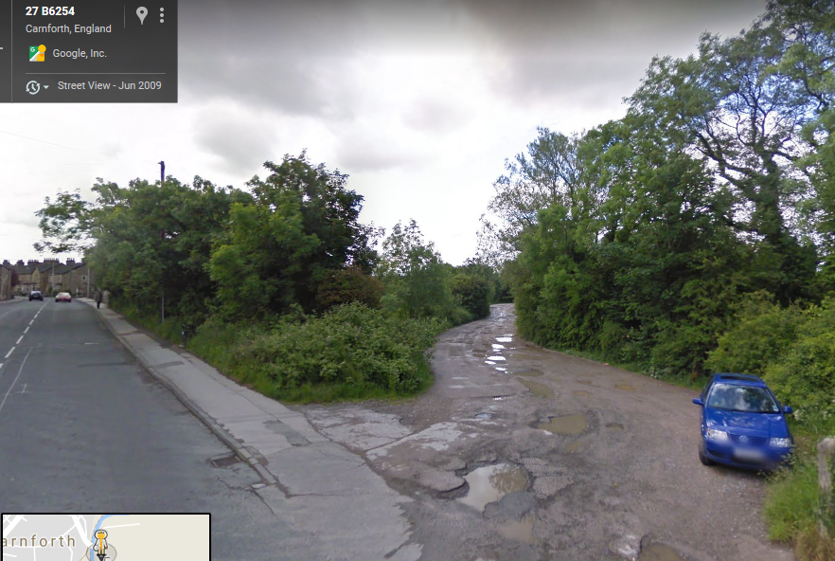
Point A
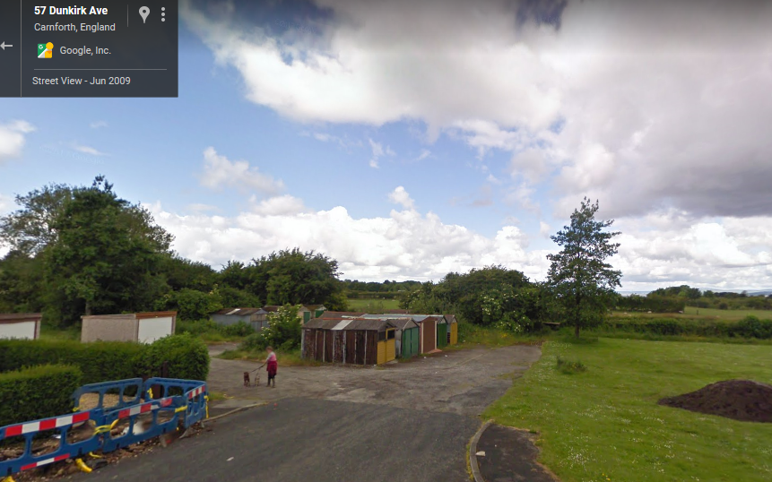
Point F
Observations |  | Access onto the application route is open at point A with no signage apparent indicating whether or not the route was considered to be public or private. The track appears to be heavily used by vehicles (indicated by its width and pot holed surface).  Access onto the application route from point F at the junction of Dunkirk Avenue and Windermere Road appears open and available past the garages.
Investigating Officer's Comments |  | Access onto the application route appears available at either end of the route (point A and point F) in 2009.

Map and photographic information provided specifically by the applicant:

Ordnance Survey map/route card |  | Route information provided by the applicant
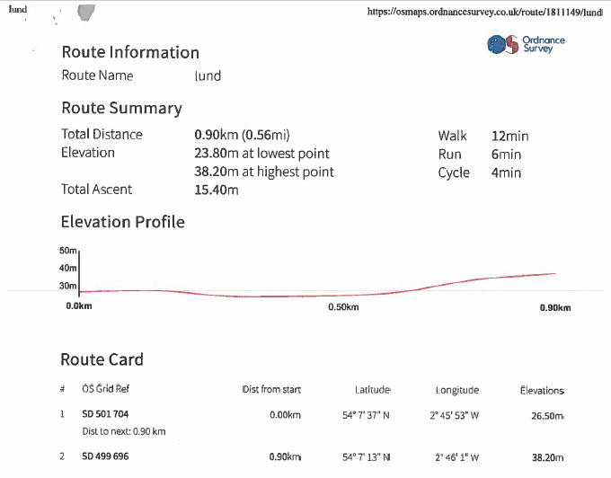
Observations |  | The route card provides information about the start grid reference point (point A) and end grid reference point (point E/F) of the route. It gives no information regarding the exact route walked between these two points or information regarding the status of the route.
Investigating Officer's Comments |  | No inference can be drawn with regards to the existence of public rights.
20 Barriers Race |  | https://20barriersracecarnforth.blogspot.com/
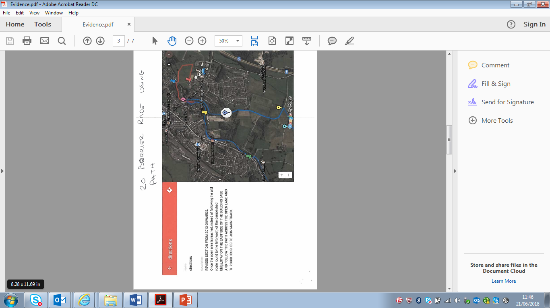
Map submitted by applicant
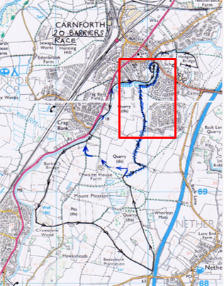
Annotated map on 20 Barriers Race website
Observations |  | An online search found a dedicated web page to the 20 Barriers Race. The race appears to be an annual event supported by a running shop (the runners centre) in Lancaster with part of the proceeds from the event being donated to charity.  The event is described as following a 5.5 mile scenic route on the field paths, trails and canal towpath in the countryside to the south of Carnforth ‘Gateway to the Lake District’.  The website explains that the race gets its name from the number of stiles and other field boundaries crossed along the route but it is stated that none of the ‘20 barriers’ should present any unusual hazards or difficulties.  In relation to the 2018 event (held on 3rd July) it is stated that 'following the closure of the Lundsfield track to the public in early 2017 the race now finds its way back to Carnforth via Thwaite End Bridge number 127' and an annotated extract of an Ordnance Survey map is provided showing the revised route with the former route – which followed the application route between point A and point E – scribbled out with a blue pen.  The Investigating Officer made contact with the current race organiser who explained that he had taken over organising the event in 2004 from a former Carnforth High School teacher who started it off in the mid-1990s and that the event had been run every year since (with the exception of 2001 when it wasn't run due to the foot and mouth out outbreak).  He explained that prior to the closure of the quarry site the race had included use of the application route between point A and point E and that as organisers they never sought permission to stage the race over this land with the landowner as it was an unused post-industrial site which for all intent and purposes appeared to be open to the public.
Investigating Officer's Comments |  | The route appeared to have been capable of being used (between point A and point E) since the mid-1990s and had a local reputation of being open and available to the public.
Picture of Quarry showing public using path | Undated
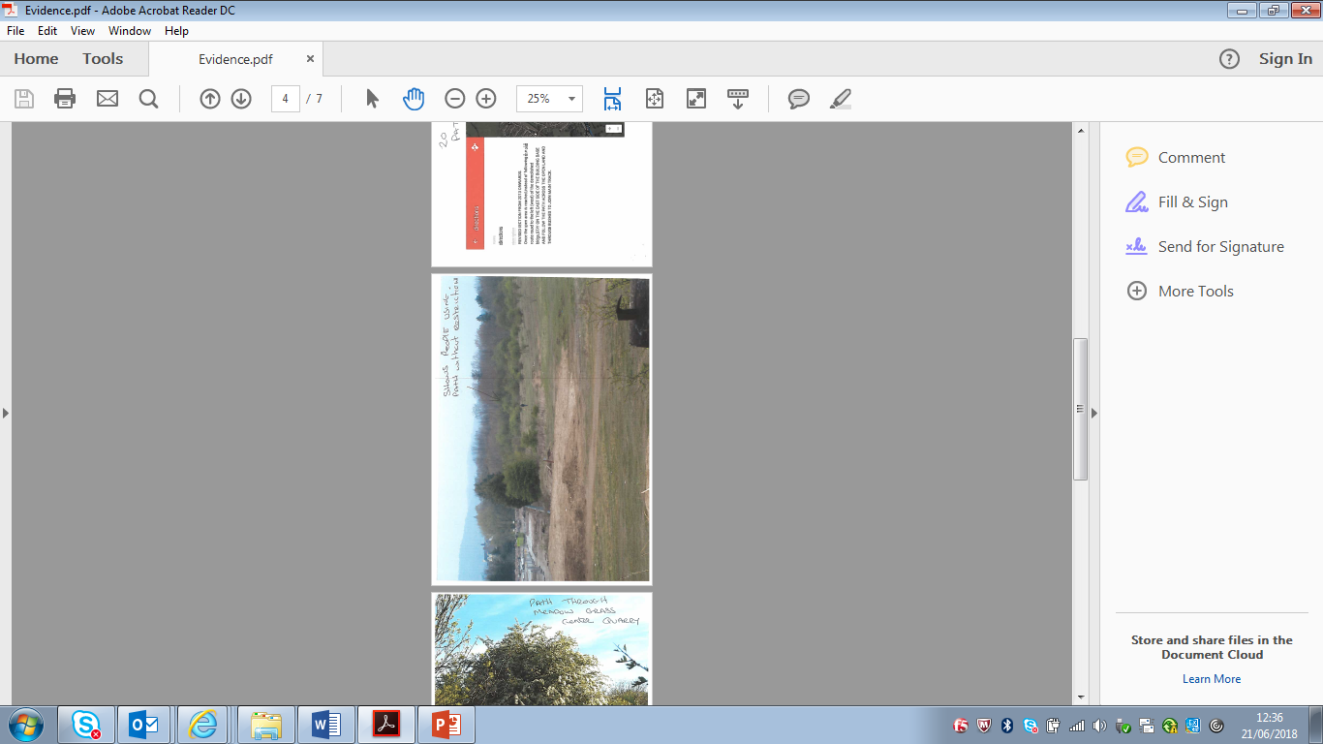
Observations |  | The undated photograph appears to show a person walking to the east of the application route between point B and point C. The photograph was taken after the buildings on the site had been demolished but the exact date is not known.  It is not known why the person on the photograph was walking across the site or whether they had been given permission to be there.
Investigating Officer's Comments |  | No inference can be drawn with regards to the existence of public rights along the application route.
Picture of centre Quarry Path through meadow grass | Undated
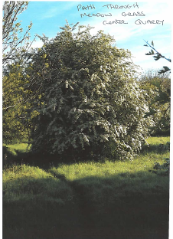
Observations |  | The date or exact location of the photograph is not known.
Investigating Officer's Comments |  | No inference can be drawn with regards to the existence of public rights along the application route.
Picture north side of path, known as Tipping Road | undated
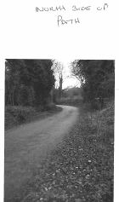
Observations |  | The photograph is undated but shows the application route between point A and point B.
Investigating Officer's Comments |  | No inference can be drawn with regards to the existence of public rights along the application route.
Picture of south side of path towards Dunkirk garages | Undated
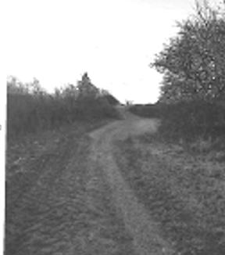
Observations |  | The photograph is undated but is understood to show the application route between point D and point E.
Investigating Officer's Comments |  | No inference can be drawn with regards to the existence of public rights along the application route
Detailed drawing of plants and their position
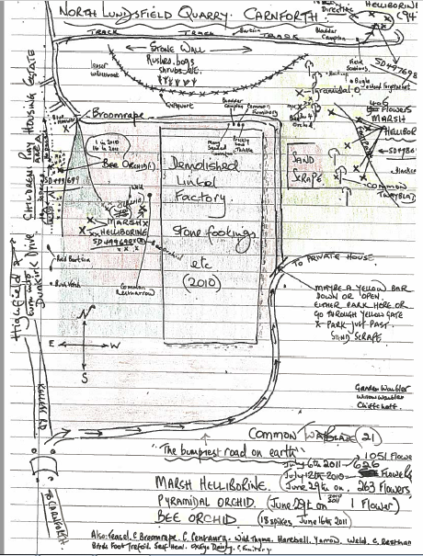
Observations |  | The very rough hand drawn plan is said to be drawn from a 2010/11 survey of plants found on the site. The Applicant has explained in the application that the hand-drawn map illustrates the fact that people could take their time passing through the land without being 'ordered or restricted from doing so'.  It is not known who produced the plan or whether they had been given express or implied permission to be on the site. The plan shows parts of the application route – for example the track from A-B is described as the bumpiest road on earth – and there is reference to the fact that a yellow barrier (which is on the west side of the concrete area and not affecting the application route) determined the place to park.  The track shown past the 'demolished lintel factory' appears to be to the west of the application route with the application route between point B and point C not shown. A track consistent with the application route from point D towards E is shown. (Note: the compass drawn on the map is incorrect and the topography very approximate).
Investigating Officer's Comments |  | No inference can be drawn with regards to the existence of public rights along the application route.
Map showing biological heritage site

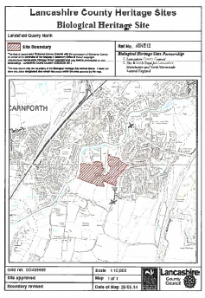
Observations |  | The plan submitted by the applicant shows the boundary of the biological heritage site known as Lundsfield Quarry North. The application route crosses the site between points B-C and C-D.
Investigating Officer's Comments |  | No inference can be drawn with regards to the existence of public rights along the application route.

The affected land/specified parts of the land is not designated as access land under the Countryside and Rights of Way Act 2000 and is not registered common land.
The route crosses an area of land designated as a biological heritage site for a short section midway between point B and C and between point C and D.

Landownership

The section of the route between points A and E is registered to the Homes and Communities Agency (now Homes England) of Arpley House, 110 Birchwood Boulevard, Birchwood, Warrington, WA3 7QH.

The section of the route between points E and F is registered to Lancaster City Council of Town Hall, Dalton Square, Lancaster, LA1 1PJ.

Summary

The application is for the route to be recorded as a public footpath.

To summarise, the Investigating Officer was of the opinion that there was insufficient historical map and documentary evidence from which public rights could be inferred.

It appears that the route applied for existed in part since the late 1800s (between point A and point B) but did not exist as a through route to Dunkirk Avenue/Windermere Road until possibly the 1960s.

The route from point A to point B formed the main access into the quarry site and more recently to the football pitches and marina and is consistently shown as a substantial track since the 1800s. However, the route between point B and point C is not clearly shown on any of the map or photographic evidence examined and whilst it may have been accessible, particularly since the closure of the quarry site further clarification is needed form users of the route. The map provided as part of the 20 Barriers Race – which has run since the mid-1990s – shows the route A-B-C-D-E as forming part of the route suggesting that it was accessible since that time.

No information could be found about when the quarry ceased to operate and whether public access was available during the time the quarries were in use (although at least one of the users detailed below refers to using the route whilst the quarry was open).

Head of Service – Legal and Democratic Services Observations

Information from the Applicant

The application was supported by the following:

- 12 User Evidence Statements
- Ordnance survey map/route card
- Ordnance survey map showing route
- 20 Barrier Race circuit map
- Picture of Quarry showing public using path
- Picture of centre Quarry Path through meadow grass
- Picture north side of path, known as Tipping Road
- Picture of south side of path towards Dunkirk garages
- Detailed drawing of plants and their position
- Map showing biological heritage site

User Evidence

There were 12 User Evidence forms provided with the application.

The application route use varies between the years 1972 and 2017.

10 users have used the route over a continuous period of 30 or more years up until 2017; 1 user had used the route for at least 20 years until 2017; and another user had used the route for 12 years up until 2017.

Usage up until 2017:

 | Daily Basis | Weekly | Monthly | Other
Foot | 6 | 6 | 0 | 1  (12 years user) between 2005-2014 only when visiting
Bicycle | 0 | 0 | 1 | 0

All 12 users confirmed that the application route has always followed the same course and that they have seen others using the route at the same time that they have been using it.

Whilst using the route all users provided that they saw other users on foot using the same route as them; 2 users saw people using motorised vehicles; 3 users saw other users on bicycles; and 1 user provided that they saw someone on horseback using the route.

The main reasons for the use of the route were for pleasure, dog walking, walking into Carnforth to access the shops, exercise and playing in the quarry as a child.

11 users confirmed that they have never seen any signs or notices suggesting that the route was not a public right of way. 1 user provided that they once saw a sign but could not remember what it said. Another user provided that they once saw a sign saying "no motor cycles".

8 users answered "yes" to there being stiles on the route; 5 of the users marked and described the stile as being at the Dunkirk Avenue end of the route; 2 users answered "no" to there being stiles on the route and 2 provided no answer to the question.

1 user provided that the stile has been there for 30+ years; 2 were not sure; 3 provided that it has always been there; and another provided that it has been there as long as they could remember.

6 users provided that there have never been any gates on the route; 1 user didn’t provide an answer; 3 users answered "yes" that there are gates on the route; 1 user provided that a barrier gate was installed to prevent cars tipping south of the football ground on the route.

1 user provided that gates and fences were erected in April 2017 which were locked barring access to the route at either end of the route, 1 user provided that they have been prevented from using the route due to gates and fences (from 2017) and another user provided that they were not prevented from using the route until the HCA erected metal barriers in summer 2017. None of the other users provided that they have been prevented from using the route due to gates, stiles or fences. However 1user marked at 2 points on the plan attached to their user evidence form 'gates erected April 2017' and 'gate/fence erected and locked April 2017.

1 user provided that 'during the 2001 foot and mouth outbreak access was restricted until October 2001 by order of DEFRA.'

All 12 users answered "no" to having worked for the landowner whilst using the application route.

10 users answered "no" when asked if they had been given permission from a landowner (or seeking permission from a landowner) to use the route; 1 user didn’t answer the question; and 1 user answered "no" but provided that when they contacted Hartley's Quarry to report fly tipping they informed them that they use the path twice a day but they were not told that it was not a public right of way during the conversation.

None of the users have ever been told that the application route was not a public right of way, nor have they been turned back whilst using the route. None of the users have heard or been told of anyone being prevented or turned back whilst using the route.

None of the users have ever had a private right to use the route.

When asked approximately how wide the application route is there was a wide range of answers:

- Changes as you walk the route
- Varies from 1m to 25m (2 people can pass at narrow 1m sections)
- It’s a field
- Varying from 2-3m, widening to width enough for 2 vehicles to pass at football ground
- 2m
- 5ft
- Path 600m wide fields
- Varying from 4m – 3ft
- Varying from 3m to 2ft
- Varying from a wide lane of 10yrds to footpath width

Below is a table of surfaces the users described the surface of the route being made up of:

Surface | No of users
Compacted Hard core | 1
Grass | 8
Gravel | 9
Soil/Earth | 5
Sand | 3

Additional comments made by users are as follows:
- "In all the years I've used the path I've never come across any restrictions, I also use the path for access to nearby villages".
- "I have used it for years with absolutely no restriction. Always used it for access through the fields to get to other villages".
- "I was told about this footpath by the previous residents of my house. They showed me where it was and they said they too had used it "for years". I am also concerned that the continuation of this path (Left turn as the garage access) has also been blocked off. This has been a footpath for the same period of time".
- "Walked my dog for years while been a working Quarry. Never was restricted from using the path".
- "We have had unrestricted access to Lundsfield and its various tracks for over 30 years. My family have walked and cycled nearly every day. When our sons were younger they played in Lundsfield, making BMX tracks; picked blueberries in autumn".
- "We have enough things taken away as it is!"

Information from Landowners

Trowers & Hamlins LLP acting on behalf of one of the landowners, Homes England object to the application.

They requested a copy of the application which was sent 17th April to them. We are yet to receive any comments on these documents.

They state that their client is currently developing the site and has taken exhaustive steps to give notice (by signage on site), that the land is private property, potentially unsafe and unsuitable for public access.

Information from others

Neil Herbert on behalf of the Lancaster Group of the Ramblers Association have no objections to the application. They provided the following comments:

- There is a similar route in their potential list ways claims, L.1-13.02, Tipping Lane.
- A second claim, L.1-03.03 Carnforth 29 could be linked in with this application since 1-3-FP29 does not end on a PRoW.
- The route is well used by the local community. Currently the route has closed steel gates at both the Kellet Road and near the Dunkirk Avenue end. In the past the path would have been used for access to the quarry but more recently for the football ground, marina and Carnforth centre as well as for general exercise.
- Since the area appears to be subject to an imminent planning application, maybe best to await this application and then develop the most suitable route to suit all parties.

Assessment of the Evidence

The Law - See Annex 'A'

In Support of Making an Order(s)

- User evidence

- Absence of action taken by the landowners to discourage use of the route until recently

- Absence of signs and notices along the route suggesting that the route was not public until recently

- Map and documentary evidence showing that part of the route (A-B) existed since the late 1800s

- Map provided as part of the 20 Barriers Race suggesting that the route A-B-C-D-E was accessible since the mid 1990s

Against Making an Order(s)

- Insufficient historical map and documentary evidence from which public rights could be inferred

- Recent locking of gates and barriers along the route

Conclusion

The claim is that the route A-B-C-D-E-F has already become a footpath in law and should be recorded on the Definitive Map and Statement.

It is therefore advised that as there is no express dedication that Committee should consider, on balance, whether there is sufficient evidence from which to have its dedication inferred at common law from all the circumstances or for the criteria in section 31 Highways Act 1980 for a deemed dedication to be satisfied based on sufficient twenty years "as of right" use to have taken place ending with this use being called into question.

Considering initially whether there are circumstances from which dedication could be inferred at common law. It is advised that Committee has to consider whether evidence from the maps and other documentary evidence coupled with user evidence indicates that it can be reasonably inferred that in the past the landowner(s) intended to dedicate the route as a public right of way. Considering the historical map evidence it is suggested that there is insufficient historical map evidence from which public rights could be inferred. However, whilst it is suggested that the way this route is recorded on documentary evidence is not itself sufficient circumstances from which dedication could be inferred, sufficient as of right use acquiesced in by the owners may also be circumstances from which dedication can be inferred. From looking at the user evidence it would appear that until 2017 no clear actions were taken by owners and use by the public continued over several years prior to 2017 such that on balance there may be sufficient evidence from which to infer dedication at common law.

Looking secondly at the criteria for a deemed dedication under section 31 of the Highways Act 1980; use of the route needs to be by the public 'as of right' (without force, secrecy or permission) and without interruption over a sufficient 20 year period immediately prior to the route being called into question. In this matter the evidence indicates that access to the route was denied in or around April 2017 by the presence of locked gates and fences. With regards to the reference by one user of the route being restricted in 2001 as a result of the foot and mouth outbreak, the Planning Inspectorate Advice Note 15 (Breaks in User caused by Foot and Mouth Disease) provides that 'it does not seem that the temporary cessation of use of ways solely because of the implementation of measures under the Foot and Mouth Disease Order 1983 could be classified as an “interruption” under section 31(1).' Accordingly, the 20 year period under consideration for the purposes of establishing deemed dedication would be 1997-2017.

The applicant has provided 12 user evidence forms which show use of the route from as early as 1972. All 12 users have provided evidence of use during the period under consideration and all users refer to having witnessed other users whilst using the route. All users claim to have known and used the route on foot on a regular basis 'as of right' with one user also having used the route on pedal cycle. Whilst 2 of the users refer to having seen signs, 1 could not recall what the sign said and the other stated that he once saw a sign saying 'no motor cycles.' None of the users have ever been told that the route was not a public right of way nor do any users refer to having been turned back or having asked permission to use the route. It is therefore suggested that the user forms indicate that on balance, the route has been used as of right and without force, secrecy or interruption during the period under consideration.

An objection has been received from one of the landowners, Homes England. However, whilst this objection is acknowledged, it is submitted that the concerns raised are not relevant considerations under either section 31 Highways Act 1980 or under Common Law.

On balance and after careful consideration, it is suggested that the criteria under section 31 Highways Act 1980 can be satisfied. Taking all of the information into account Committee may consider that a dedication of a footpath can be deemed or inferred and that it is appropriate that an Order be made and promoted to confirmation.

Risk management

Consideration has been given to the risk management implications associated with this claim. The Committee is advised that the decision taken must be based solely on the evidence contained within the report, and on the guidance contained both in the report and within Annex 'A' included in the agenda papers. Provided any decision is taken strictly in accordance with the above then there is no significant risks associated with the decision making process.

Local Government (Access to Information) Act 1985

List of Background Papers

Paper | Date | Contact/Directorate/Tel
All documents on File Ref: 804-589 |  | Claire Blundell, 01772 535604, Legal and Democratic Services
Reason for inclusion in Part II, if appropriate

N/A

The Ordnance Survey (OS) has produced topographic maps at different scales (historically one inch to one mile, six inches to one mile and 1:2500 scale which is approximately 25 inches to one mile). Ordnance Survey mapping began in Lancashire in the late 1830s with the 6-inch maps being published in the 1840s. The large scale 25-inch maps which were first published in the 1890s provide good evidence of the position of routes at the time of survey and of the position of buildings and other structures. They generally do not provide evidence of the legal status of routes, and carry a disclaimer that the depiction of a path or track is no evidence of the existence of a public right of way.
Aerial photographs can show the existence of paths and tracks, especially across open areas, and changes to buildings and field boundaries for example. Sometimes it is not possible to enlarge the photos and retain their clarity, and there can also be problems with trees and shadows obscuring relevant features.

